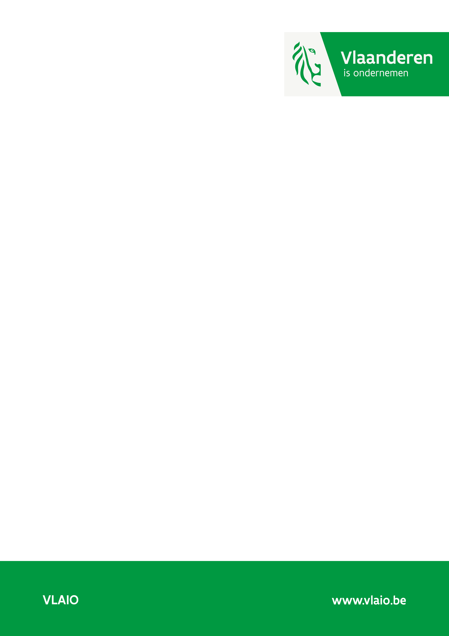

Research Projects Application Document, Impact Section
  - Version MAY 2024

Track record (max. 1 page)

If you have received innovation support through VLAIO in the last 5 years, provide a clear description of its impact for each business partner. This will help us understand the impact the supported projects have had on your business.

If you have not received support through VLAIO in the last 5 years, you may delete this section.

Project number | The impact generated by the project since completion
xxxx
xxxx

Project number | xxxx | xxxx | xxxx | xxxx | …
Project title
Subsidy amount granted
Staff*
R&D budget**
Investments**
Labor productivity***

*Start from the year of completion of your first project and show the process to the year in which the present project was submitted.
**Focus on R&D and investments made as a result of supported projects. Spillover effects within your company may also be included (briefly explain how these are linked to the supported projects).
***Only to be completed if projects with growth in labor productivity as added value for Flanders have been supported in the past. Labor productivity = Gross Value Added (BrTW) / number of FTE. For the definition of Gross Value Added, please refer to the Explanatory Document. The number of FTEs does not include freelancers.

Impact
In this section, explain how the realization of this research project will create value for the business partners and for Flanders.

Please stick to approximately 10 pages per business partner, including figures.
This section will be shared with external experts. Any detailed information that must not be shared with external experts should be included as an attachment.

1.1 The project’s strategic importance to the company
Describe the research project’s broader strategic importance to the company. Broadly outline the company's position in this area relative to other companies and stakeholders with relevant knowledge.

Describe and substantiate how the research project can make a difference to the company. Position the research project - if necessary - in a broader industrial R&D/innovation strategy.

1.2 The project result’s added value to the company
Specify how the intended knowledge accumulation within this research project can be converted into solid innovations/results in the (longer) term, and how it provides a clear competitive advantage for the company. Describe these innovations/results. How, and to what extent, will they contribute to the further development (growth, retention, diversification, transition to other business models/activities/platforms, breakthrough innovations) of the company in the (longer) term? If relevant, how will the results contribute to the intended societal added value?
For large companies only: frame the project within the company-level roadmap, which should address the following topics:
- Embedding in the Flemish ecosystem: structural collaborations with knowledge institutions and SMEs.
- Strategic roadmap of the location in Flanders. It should be consistent with policy priorities: Energy/climate, circular economy, environment, biodiversity and water management, sustainable food and nutrition strategies, mobility and smart cities, education and competencies and health and care
- Steps that the company (in particular the Flemish location) aims to take in terms of sustainability.

1.3 Follow-up trajectory
Discuss the efforts (further R&D, implementation activities, investments, etc.) needed within your company (and with partners) after the project until the expected market launch. Include the expected time frame to get there.

1.4 Valorization in Flanders: economic impact
In this section, provide a quantified justification of the total expected economic impact in Flanders based on either expected employment and investments or expected growth in labor productivity during the valorization period. These two options cannot be combined.

Option 1 - Added value for Flanders based on employment and investment
When the added value for Flanders is based on employment and/or investment, the total economic impact must be at least 10 times the support (a leverage of 10). The valorization period (= period after the project in which the project results are applied and/or commercialized) is 5 years. Subject to thorough justification, a valorization period of up to 10 years can be observed. This additional justification will be included in any further evaluation. Subject to thorough justification, a valorization period of less than 5 years can also be considered.

Option 2 - Added value for Flanders based on growth in labor productivity
When the added value for Flanders is based on growth in labor productivity, it must first be justified why the tightness of the labor market does not allow the company to realize the impact through employment and/or investment. It is required that labor productivity is at least 50% higher 5 years after the end of the project than the labor productivity at the time of application. If the support needed is more than €250,000, the cumulative additional Gross Value Added (BrTW in Dutch) must be at least 10 times the support. If the support is less than or equal to €250,000, the cumulative additional Gross Value Added may be less than ten times the support. The valorization period for projects that focus on labor productivity is fixed at 5 years and cannot be extended.

In case of multi-partner projects, each business partner should separately describe and quantify the impact of the project on their company. Here, one business partner or a group of business partners may choose impact based on employment and/or investment and the other business partners may choose impact based on growth in labor productivity. For both options, the minimum added value must be achieved.

The impact for Flanders can best be demonstrated in a table for which a possible table structure must be provided at the end of this application document.

Consider the valorization period after the end of the project and describe what activities will happen in Flanders (follow-up R&D, implementation, commercialization) until 5 years after the end of the project. What positive consequences will this have for Flanders (employment, investments, growth in labor productivity, anchoring, strengthening cooperation with the Flemish innovation ecosystem, maintaining production in Flanders, strengthening the position of the Flemish establishment in an international company through a high innovation capacity, unique know-how, etc.)? Explain as concisely as possible.

This information may also be processed in a table showing the structure of the business case. An example of such a table can be found at the end of this application document (revenue).

1.5 Social impact
If your innovation leads to a social impact, clarify it here.
A project can achieve social impact in several areas. You will find a non-exhaustive list of areas where potential societal benefit can be achieved in the explanatory document. Specify the domain in which your project is valuable and explain why.
Estimate the (global) potential monetary net gain (costs saved and/or profits gained) and specify - if applicable - what this means for the Flemish ecosystem. In addition to the direct gains or savings described under economic impact, these can include gains or savings in terms of the environment, mobility, absenteeism, etc., which impact a broad target group of stakeholders in Flanders (companies, social sector, government or citizens).
If your project has no specific social impact, leave this blank. Projects with a negative social impact are not eligible for support.

1.6 Intellectual property
Can you safeguard the results? What is your intellectual property strategy? Take the potential impact of the European patent with unitary effect which took effect on June 1, 2023 into account.

In case of collaboration (with business partners, research institutions, subcontractors): what are the basic principles for mutual agreements? Explain matters such as property and usage rights to the project results and/or any necessary background knowledge.

1.7 SWOT regarding valorization
Discuss the strengths and weaknesses of the company and important external factors (market, competition, environmental factors, etc. for both opportunities and threats) related to the valorization of the research project, as well as any other related projects. Also indicate how you will respond.

Discuss what cybersecurity measures will be taken, both at the company level and specifically for the innovation for which support is being requested. Things that will be included during the project, in support of the innovation, should be mentioned in the work plan.

Optional: additional information
You can provide any specific or detailed information that may not be discussed with external experts (e.g. the business plan) here. This must be uploaded as a separate document (attachment).

Importance of the support
Why is Flemish support important to your research project? Specify why this research project is operationally difficult, not feasible or less feasible without financial support from VLAIO.

Project with possible military affinity (if applicable)
More information on submitting projects with possible military affinity can be found here.
If this paragraph does not apply to your project, you may delete it.
If it is a project with possible military affinity, you must first indicate under which section of the Military List or Dual Use List the innovation falls.

If the project aims to realize products or systems as described under the headings of the Dual Use List, you must clearly indicate and substantiate the expected turnover in civilian and military application areas when elaborating the business case of your project (see 1.2 Expected valorization opportunities).

If the project falls under headings ML5, ML6, ML7f-i and ML8-ML22 of the Military List or under those of the Dual Use List and the business case clearly indicates that the application is primarily military, the file will be submitted to the Ethics and Strategic Advisory Committee for advice. In that case, you will be asked to complete a self-evaluation during the evaluation process.

Table of added economic value for Flanders

Option 1 - Added value for Flanders based on employment and/or investment

Impact calculation based on employment and/or investment | XXXX  (year) | XXXX | XXXX | …… | …… | Total
Extra employment because of the project (break down per profile such as employees, vendors, R&D, etc.) - to be expressed in FTEs
Sustained employment because of the project - to be expressed in FTEs
Payroll costs - new hires
Payroll costs - staff retention
Project-related investments
…

Note that the increase in revenue that can be realized thanks to the project is not part of the leverage calculation. The input for the leverage calculation consists only of labor costs and investments as calculated is the table above.

Option 2 - Added value for Flanders based on growth in labor productivity

The table is best constructed based on the definition of Gross Value Added (BrTW) as described in the Explanatory Document. Labor productivity (AP in Dutch) is calculated as AP = BrTW/FTE. As explained in the Explanatory Document, the number of FTEs must remain virtually constant for eligibility. This means that the growth in labor productivity is primarily realized through an increase in BrTW. It is therefore important to document the factors that determine the BrTW in your company and those that are impacted by the project results. Also, assumptions need to be substantiated and you must indicate why they are realistic.

The BrTW can increase because of:
- an increase in operating revenue. This is typically an increase in sales due to new or improved products, services or processes. This has already been justified in the table under heading 1.4 Valorization in Flanders - economic impact;
- a decrease in operating costs: it may be that thanks to the project, fewer raw materials will be needed for production, fewer operational subcontracting costs will be required, less energy or water will be consumed, fewer (external) IT costs are necessary, the project will lead to more predictable and efficient inventory management, etc.

Impact calculation based on growth in labor productivity | On request | XXXX (= 1 year after end of project) | XXXX (= 2 years after end of project) | XXXX (= 3 years after end of project) | XXXX (= 4 years after end of project) | XXXX (= 5 years after end of project)
Calculation BrTW
- Factor X that affects the BrTW due to the project results
- Factor Y that affects the BrTW due to the project results
- …
- Total of the factors of the BrTW that are not affected by the project results
- Evolution BrTW (= sum of the rows above)
Evolution of FTEs (permanent employees only, not freelancers)
Total return for Flanders
- Evolution AP = BrTW / FTE
- Growth in BrTW (incremental compared to starting value) | N/A
- Growth in BrTW (cumulative) | N/A

Conceptual example of a table to support the business case
Revenue | XXXX  (year) | XXXX | XXXX | …… | …… | Total
Revenues from product/service X based on the business drivers (add additional columns or rows according to need and if relevant, split according to the situation with and without a project)
Revenues from product/service Y based on the business drivers (add additional columns or rows according to need and if relevant, split according to the situation with and without a project)
…
Total revenue
Start at the end of the project (column 1) until 5 years after the end of the project. This table should reflect the project’s expected growth. In the text, clearly describe the assumptions and justify why they are realistic.

Additional information
Your application will be evaluated according to the criteria in Annex 1 of Explanatory Document on Research & Development Projects and Feasibility Studies. To assess the criteria of "additionality," "impact" and "potential to achieve the impact," VLAIO bases its assessment primarily on the submitted application document. VLAIO will also always seek the advice of external experts. Therefore, please fill out this document clearly and fully. Especially for large and/or complex projects, VLAIO may request additional information and/or documentation (e.g. with regard to numerical substantiation of the valorization prospects) to allow for a correct assessment.

When your application is being processed, a meeting with a VLAIO project advisor will take place. During this meeting, we will discuss the information in the application such as the justification for your valorization prospects.

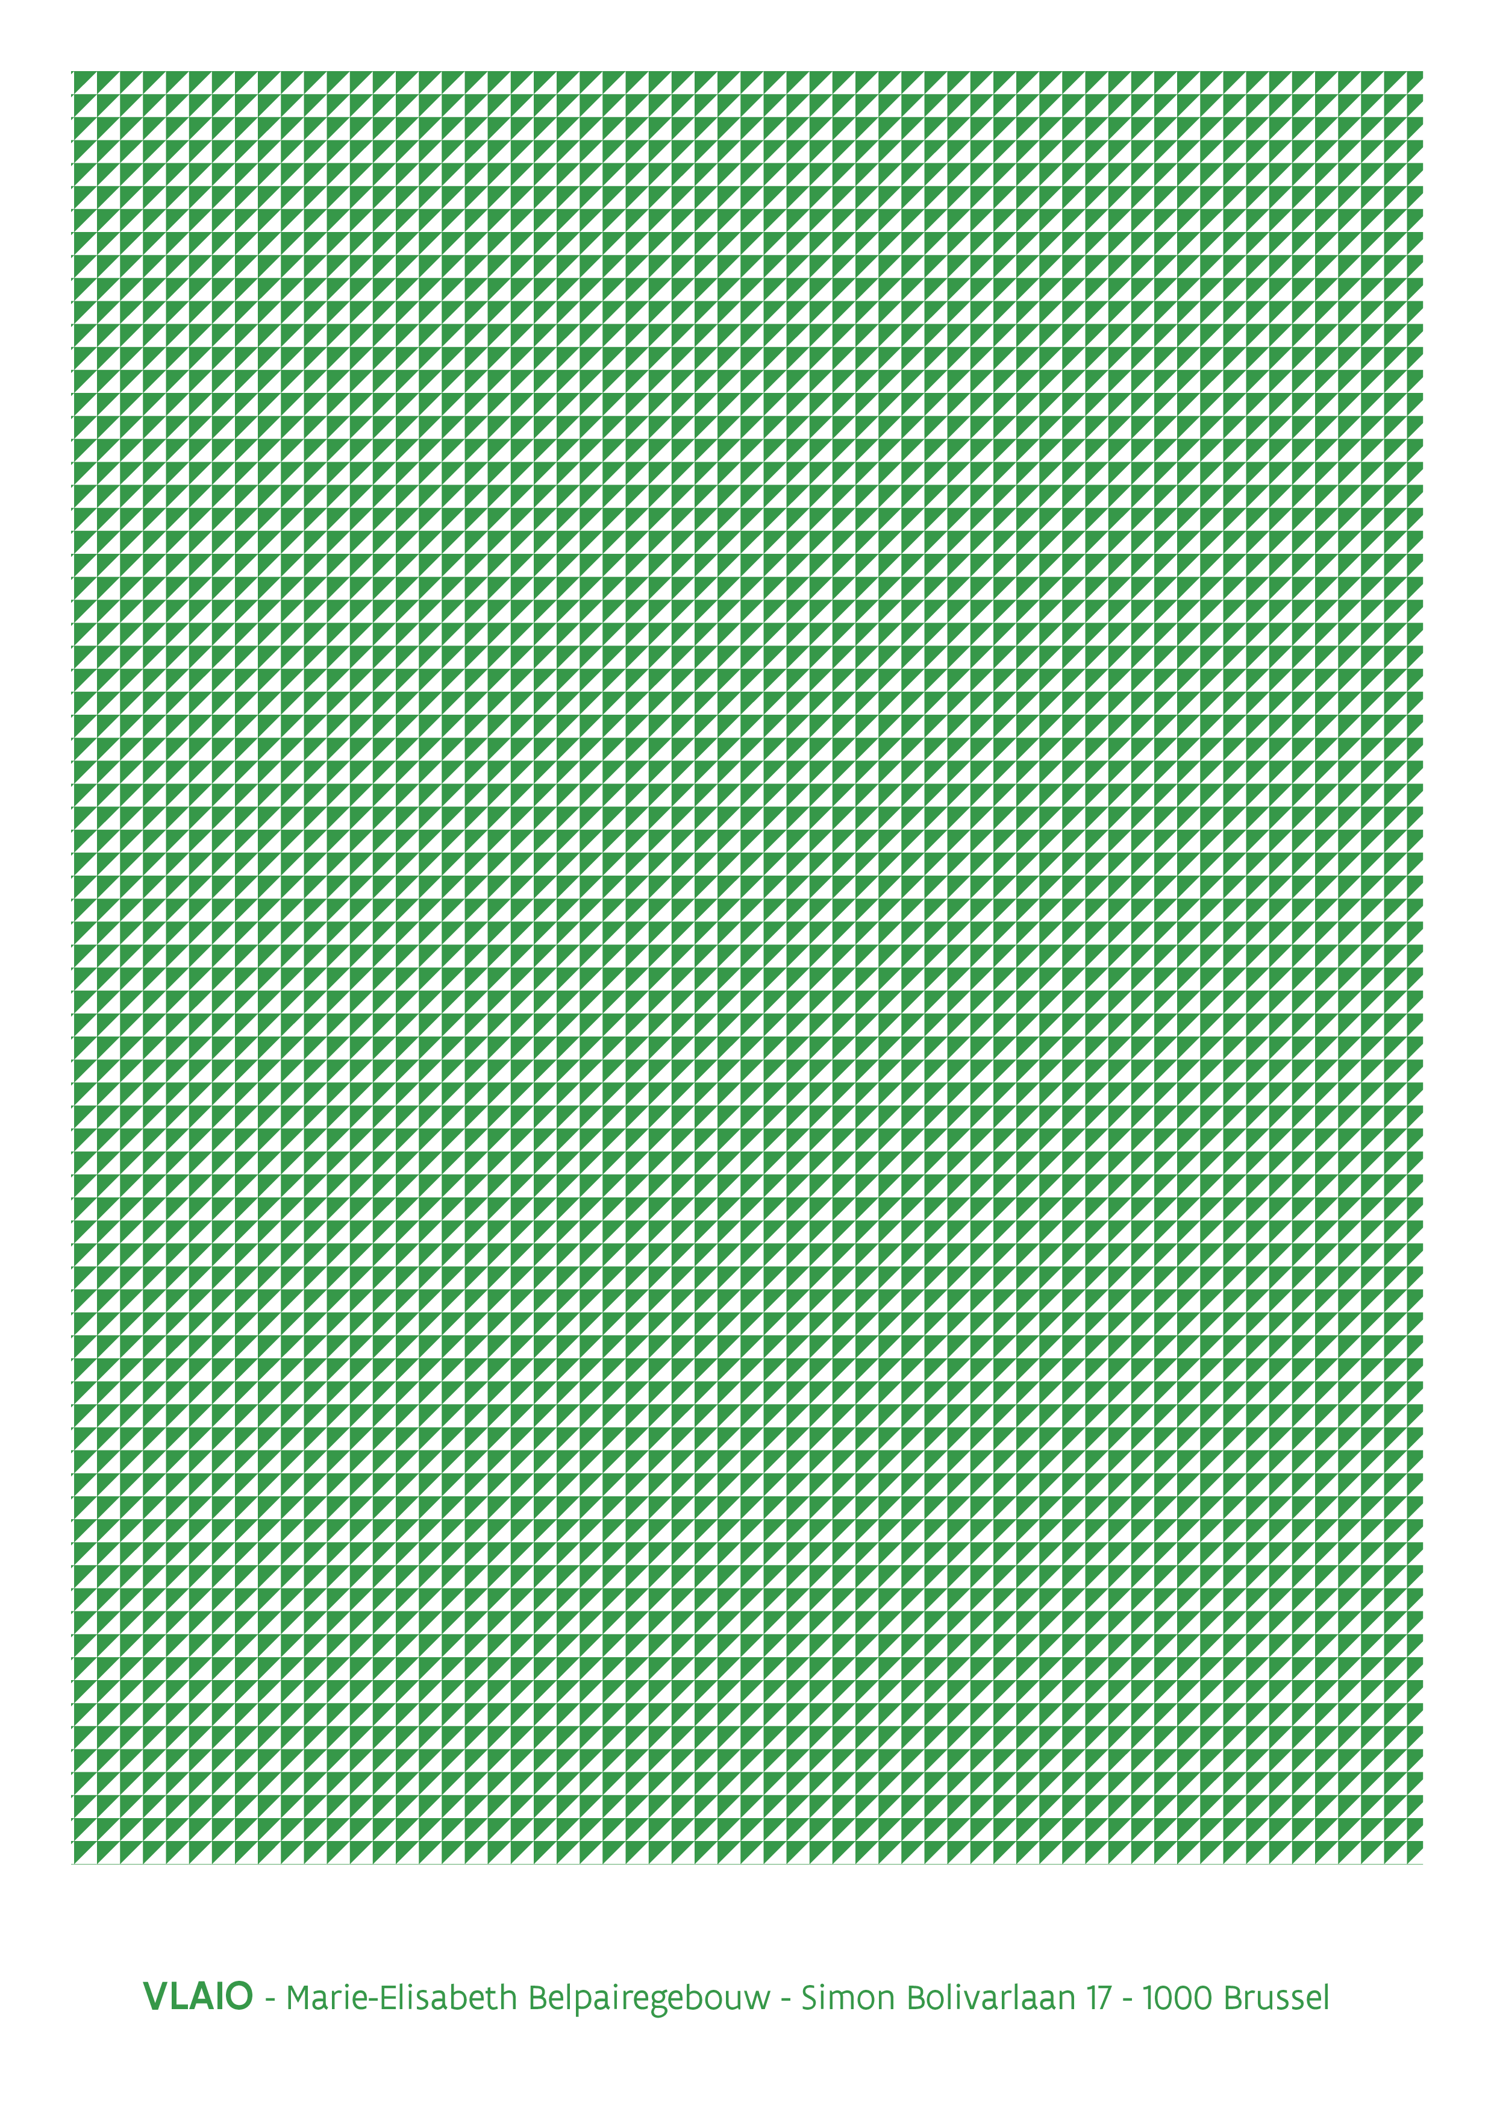

Make sure to clarify how the staff costs are structured (how many FTE of which staff type and the salary costs per staff type). If relevant, this can be broken down in the table.
No support can be provided to companies that realize all or part of the growth in labor productivity through layoffs. This means that the number of FTE must remain virtually constant during the valorization period.

