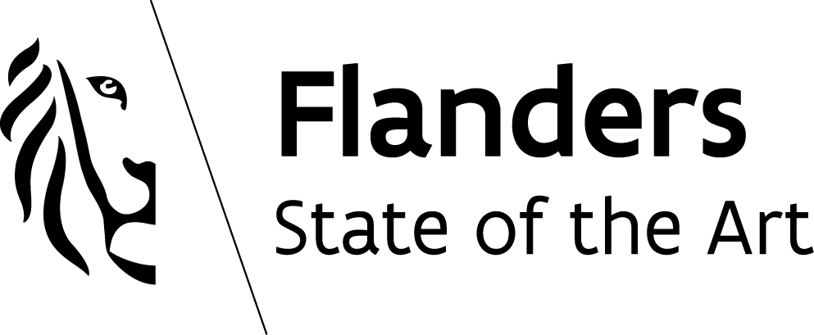
www.vlaio.be

Application

R&D projects,

part financial information

for large companies
  - Version valid from January 2020

Activities and results

Important business changes of the last two years (if applicable)
Briefly describe the main business changes of the company over the last two years, in particular with respect to the impact on the Belgian site(s), if the company is part of a group. Examples include capital increases or decreases, changes in ownership, changes in activities, changes in strategic alliances, changes in business model, etc.

Annual reports of the company and group key figures
All attachments to be separately added as requested below may be uploaded on the “financial information” page under “Financial statements: provisional / interim financial statement / international / group level”.

1.2.1. Company level
- Belgian annual reports: only to be added if the latest annual report has not yet been filed
- International annual reports: please provide the web link to the latest available international annual report or send the international annual report in a separate attachment

1.2.2. Group level
In case of consolidation – whether formally or informally – please provide the latest consolidated financial statements (highest consolidation level) in a separate attachment. Internally (informally) consolidated financial statements must be declared ‘true and authentic’ by an external accountant.

This information is required to determine whether or not the group to which you belong is qualified as an ‘undertaking in difficulty’.

Shareholders and shareholdings

For listed companies:
Please provide the name of the group or of the consolidating parent company (highest consolidation level).

For non-listed companies:
Please provide the name and % of the shares for each shareholder. In case the shareholder is a legal entity, please also provide the business/VAT number.

