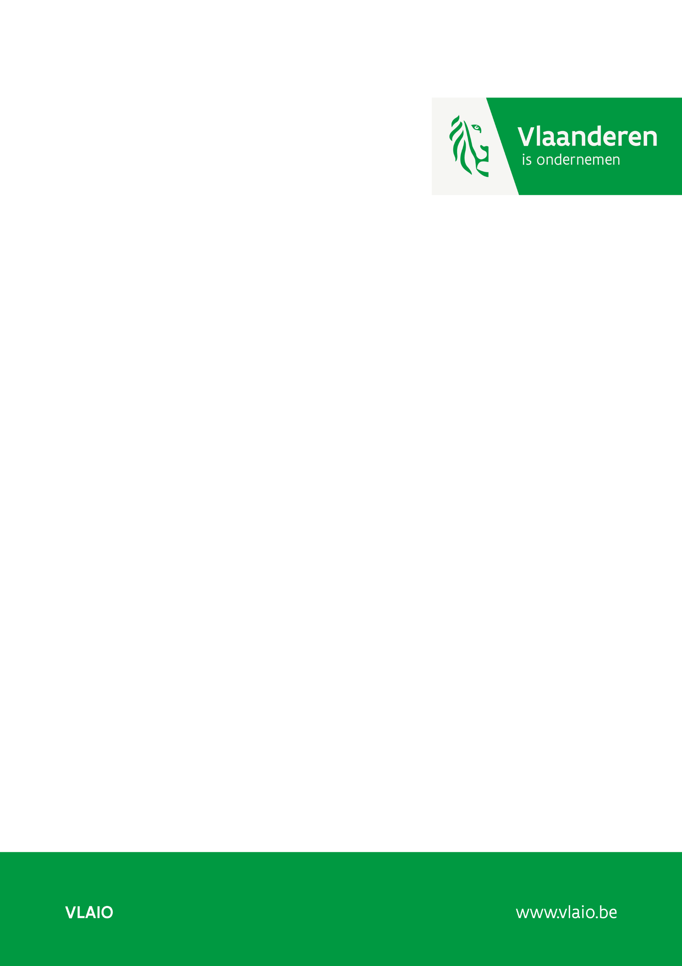

Strategic basic research
Template for submitting an application for a ‘cSBO’ project for clusters
Version: March 2026

This document explains how to complete an application for a strategic basic research project for clusters (in dutch ‘Strategisch BasisOnderzoek voor Clusters’ or ‘cSBO’) with a primary economic finality. Where relevant, the link with the cluster strategy and/or other cluster activities should always be made.

The following documents are important for the preparation of the application and can be consulted via the website (Application procedure projects for spearhead clusters | VLAIO) or available from your account manager or via clusters@vlaio.be:

- Manual Strategic Basic Research for clusters (version March 2026) with relevant background information,
- Manual for the cost model (version July 2025) and the corresponding Project Budget Template (version July 2025),
- Other documents (e.g. template extra cluster criteria, Role of research organisations spearhead clusters in ICON and ‘cSBO’, Checklist organisation for research and knowledge dissemination).

You can always check with your account manager whether you have the most up-to-date version of these documents and templates.

The application must be submitted online via the cluster with eID via the button 'Request cluster strategic basic research' in the Application procedure projects for spearhead clusters | VLAIO. The signing of the statements takes place at the time of online submission.

If you have any questions about the submission of the project application, please contact your account manager or VLAIO:

Postal address:
Flemish government
VLAIO
Koning Albert II-laan 15 bus 331
1210 Brussels

Physical office:
VLAIO headquarters
Marie-Elisabeth Belpaire building
Avenue Simon Bolivar 171000 Brussels

clusters@vlaio.be

The application

The application for a ‘cSBO’ project consists of 4 different parts and 3 appendices:

- Part 1. Project sheet and project summary (in English -max 3 pages)

- Part 2. Description of the intended valorisation and knowledge transfer (in English – max. 25 pages)

- Part 3. Scientific project description (in English – max. 30 pages)

- Part 4. Expertise and track record of the consortium (in English – max. 5 pages * N with N = number of participating research groups)

- Appendix A Administrative data, letters of intent project implementers, letter of intent of the cluster organisation(s) involved, the project summary in Dutch and for the public

- Appendix B Additional substantiation of part 2 (i.e. the valorisation chapter) of the ‘cSBO’ proposal: motivated letters from companies, any additional more confidential valorisation information (e.g. draft business plan, details of freedom-to-operate analysis)

- Appendix C Excel file with the project budget. An Excel template is available to draw up the budget. Its use is mandatory

The following general points are important for the preparation of your project proposal:

- The maximum number of pages specified for volumes 1 to 4 includes literature and other references and includes normal A4 pages with "Calibri" font, minimum font size 11 or equivalent and reasonable margins. Exceeding the maximum limits for a project proposal results in its inadmissibility! Keep in mind that these are maximums, and that a good ‘cSBO’ proposal does not necessarily have to approach this maximum limit in practice.

- Parts 1, 2, 3 and 4 of your project application are intended for the external experts and are therefore required to be written in English.

- Annexes A and B are intended exclusively for VLAIO and can be drawn up in Dutch or English, with the exception of the project summary in Dutch and for the public. In principle, these appendices are not passed on to the external experts. The Dutch project summaries in Appendix A serve as essential basic information for the Fund for Innovation and Entrepreneurship. This also forms the basis for drawing up the support agreement in the event of a positive decision. Please carefully prepare these project summaries in Dutch in line with the other parts of your ‘cSBO’ project proposal.

- No other appendices are requested than the above-mentioned Appendices A (administrative data) and B (valorisation data). Unsolicited attachments (e.g. scientific addenda, researchers' CVs) are not used in the evaluation process. The addition of unsolicited attachments may result in the inadmissibility of the project proposal.

- To draw up a ‘cSBO’ project proposal, it is essential to interact with the tech transfer service of your knowledge institution at an early stage (cf. http://www.ttoflanders.be ).

Part 1 General information: project sheet and project summary

This volume consists of a maximum of 3 pages.

  - Project title
- Title (short, informative and clear)

1.2 Basic data
- Start date (at the earliest the first day of the month following the month of submission):
- Project duration (maximum 4 years):
- Total budget requested:
- Total aid requested:
- Total mm:
- Partners:
the list of participating partners in the consortium and the names of the promoters or project leaders (i.e. without further administrative data).

1.3 Summary of scientific objectives (max. 1 page)
General goal:

Describe in a few sentences what the consortium is aiming at with this project. The general goal therefore includes the essence of the intended product, process or service innovation.

Concrete goals and criteria:

Explicitly state the partial results that must be achieved at the end of the project. This can involve new knowledge/insights that need to be acquired as well as the solution of certain problems or concrete equipment, test setups, models, etc. that must be realized.

For each sub-aspect, state the most important quantitative and qualitative target values, criteria, requirements and standards, based on which it can be determined to what extent the expected results have been achieved at the end of the project.

1.4. Summary of possible impact (valorisation) max. 1 page
Briefly describe the valorisation perspectives:

- Which applications/sectors are envisaged?
- Contribution to the strategy and objectives of the innovation cluster(s)?
- What possible impact is anticipated?
- When will results be applied by the companies?
- How will the results be transferred to companies (e.g. setting up bilateral follow-up R&D processes, company internships, licenses, etc.)?
- What willingness is there among the companies to get started with the project results?
- Describe the IPR strategy

Please also provide the list of companies that have agreed to join the supervisory committee and to work together during and after the project (if applicable). Briefly explain their possible role in the valorisation chain and their contribution to the project:

E.g.
- Company X (raw material supplier, 1,000 euros/year + test material);
- Company Y (technology provider, SME, 250 euros/year)
- Company Z (product development, 1,000 euros/year + parallel R&D projects)

Part 2. Description of the intended valorisation and knowledge transfer

This volume consists of a maximum of 25 pages.

The assessment of the valorisation chapter of a strategic basic research project proposal has an essential dimension in the selection. It is in this assessment dimension that the character of the "strategic research investment" can be estimated in terms of potential future economic value creation for Flanders. This requires a sufficiently detailed valorisation chapter with - as far as possible - quantitative indications, even though the valorisation will only be able to materialise in the long term.
The task for the applicants is to devise an optimal valorisation process. Key questions here are: What do I want to valorise? Which companies are eligible for transfer? How do I approach valorisation, also in relation to the cluster strategy?
It is essential to make your argumentation as concrete as possible in your project proposal. In Appendix B, you can add additional supporting information, such as motivated expressions of interest and commitment from the companies that join the supervisory committee.

2.1 Integration and necessity in the cluster strategy and support by the cluster members
Indicate how this project proposal and the expected results at the companies are in line with the strategy/objectives of the cluster(s) involved. Also describe how the positioning is in relation to other projects of the cluster(s) and how the interaction with these projects will take place. Explain the necessity (importance and/or urgency) of the project and the project results regarding the cluster strategy.

To what extent do the cluster members support this proposal and are they willing and ready to include the project results?

Also describe the process of the development of the project proposal and the attention paid to the valorisation orientation of the project proposal and the interaction dynamics with the users. What prior interactions with which cluster members (companies) did you have when preparing your project proposal? What impact has this had on the further development of your project proposal?

During the implementation phase of the ‘cSBO’ project, are there also R&D interactions and collaborations with one or more cluster members with a demonstrable added value for the ‘cSBO’ project? If necessary, please document this further in Appendix B.

2.2. Valorisation potential and valorisation objectives of the project
What existing problems or challenges for multiple companies do you want to address? or/and Which economic opportunities can arise from a predetermined scientific breakthrough?

Then indicate how the intended results of the ‘cSBO’ project will contribute to the solution of a problem or/and the use of the economic opportunities. Formulate valorisation objectives that are as concrete as possible, in line with the intended project results and the interaction dynamics with the users. Discuss the economic value chain and scenarios for the further course of the valorisation process.
- How big is the market/relevance of the applications? It is important to make it clear here which companies or business segments are the target group of the valorisation, and why. Do not just list companies but also clarify why the project results are important for companies. If necessary, make a distinction between possible application domains or add a matrix indicating which companies have an interest in which partial results of the project (for example, as links in a value chain).
- To what extent will (current or future) companies in Flanders be able to use the result of the project?
- What (R&D) follow-up process is needed at these companies and in the cluster to achieve effective economic valorisation? All descriptions should be quantified as much as possible.

Finally, also provide an overview of the environmental factors (e.g. regulations, policy measures...) that can strengthen the economic valorisation potential.

2.3. Valorisation strategy and approach of the project
Based on the valorisation potential, you will then develop a concrete valorisation strategy and approach.
- What activities will you undertake to help put the project results into practice and/or make them accepted within the cluster? This is not only about a list of activities, but also about the argumentation why it is precisely these activities that will bring about valorisation. Demonstrating meaningful interactions with the target groups and an active commitment of the project implementers towards valorisation is of great importance in the assessment.
- In the case of a planned transfer to existing companies, it is important to indicate what your intentions (and any agreements) are about the intended interactions with the companies. Especially in sectors and domains where exclusivity in transfer is common and appropriate, your vision as a project executor of the way of interaction with individual companies is very relevant.

- What valorisation agreements have been made between the consortium partners to optimally facilitate the efficient course of the further research collaboration and during the further valorisation process?
- Always address the potential risk factors (e.g. IPR, freedom to operate (FTO), legislation, availability of research data, or infrastructure, etc.) that may hinder valorisation opportunities in Flanders. If such risk factors are present, indicate how you will deal with them.

2.4. Added value in terms of sustainable development (if applicable)
Finally, it is important to adequately motivate and substantiate the project's contribution to sustainable development (SD) in the project application when relevant. For the time being, the definition of sustainability is limited to the contribution to environmental improvements: saving raw materials; energy saving; reducing emissions of environmentally harmful substances; reducing waste and other environmental nuisances; increasing the use of renewable resources; increasing the reuse of raw materials and the recyclability of materials and products; increase the lifespan of products and processes, increased occupational safety and hygiene. A project can be earmarked as a SD project if the applicants make it plausible with an analysis and overall estimate that the majority of the expected R&D follow-up projects will contribute to SD in the follow-up phase. After all, just like the economic valorisation perspectives, the expected environmental benefits in the long term must be reasoned from the further R&D follow-up process of a successful ‘cSBO’ project.

Part 3. Scientific project description

This volume contains a maximum of 30 pages.

...
......
...
3.1 Rationale
Starting from the intended valorisation objectives of your project, describe your scientific motivation for the project based on the scientific knowledge gaps and the questions and difficulties that you want to solve with this project. Indicate why the implementation of the strategic basic research is indispensable.

3.2. Positioning in relation to the scientific state-of-the-art
Briefly describe the state of the scientific and patent literature in the field of the project with reference to the most important sources. What background knowledge is available at the start of the project? Position your project in relation to the scientific state of knowledge and current (inter)national research. Clarify the interfaces and complementarity of your project with them.

3.3. Scientific project objectives
Describe as explicitly as possible the scientific project objectives that you are aiming for in the present project proposal. What is the essence of the intended scientific innovation based on which the various concrete goals, criteria, activities and desired results can be understood?
Explicitly state the (partial) results that should be achieved, such as specific knowledge, the solution of certain problems and the scientific breakthroughs. For each sub-aspect, state the important quantitative (preferred) and qualitative target values, criteria, requirements and standards, in such a way that at the end of the project it can be determined to what extent the expected results have been achieved.
Indicate the Technology Readiness Level (TRL) at the start of the research project and the TRL you want to achieve at the end of the project period.

3.4. Research approach and work programme
Describe the way in which the research is approached and explain why that approach is chosen and why certain strategic choices may be made. The approach must clarify how the scientific objectives will be achieved, considering the set (sub)goals and criteria, and the possibilities of the partners.

From this global approach, describe the structure and coherence of the work packages and the milestones. Also state how interim decision moments and general project risks are considered. In the work programme, describe WHAT (division into work packages), WHY, HOW (approach, working method), WHEN (planning) and by WHOM (division of tasks, synergy and complementarity).
Add a Gantt chart for clarification.

Indicate how the coordination and follow-up of the project will be organised, how the cooperation between the various partners will be structured. Please also describe the role of the cluster organisation(s) involved in relation to the project and how the project will be monitored/implemented after the possible end of the support to the cluster organisation.

Finally, provide an overview of the man-months to be spent per working year. Use the table below.

Summary table of the human months to be spent
WP | Partner | Year 1 | Year 2 | Year 3 | Year 4 | TOTAL
1 | Partner 1
 | Partner 2
 | …
2
…
TOTAL

3.5. Project budget and requested support
The project budget is based on the actual cost and is drawn up according to the principles of the innovation support cost model. An Excel template is available on the website to draw up the budget. Its use is mandatory and is described in the Guide to the cost model.

Only the global overview is copied to this section 3.5. of the application template and integrated into the PDF file for the experts.

Part 4. Expertise and track record of the consortium.

Fill in this part for each participating research group. This part is max. 5 pages * N with N = number of participating research groups.

4.1. Scientific expertise and track record
For each project partner, indicate which scientific expertise and resources (personnel, infrastructure, access to knowledge/IPR, etc.) are available at this partner to contribute to the proper implementation of the ‘cSBO’ project. Please justify your choice to include this partner in the consortium and indicate the expected synergy(ies) with the other consortium partners.

Substantiate the most relevant scientific expertise for the project for the central problem definition of the ‘cSBO’ project based on the 5 most important publications. Discuss the previous, current and planned research projects that are substantively in line with the present ‘cSBO’ project proposal, stating the funding channel (Flemish, Federal, European government support, bilateral contract with company, etc.). Provide a brief explanation of the crucial scientific successes or breakthroughs that were achieved in these previous projects. Also include an overview of the relationship and complementarity of the ‘cSBO’ project application with these related research activities.

Also discuss the existing management experience in carrying out multi-partner research projects (i.e. useful management experience in general, not necessarily in the specific topic of the ‘cSBO’ project).

4.2. Valorisation expertise and track record
Demonstrate the competence and experience available to each project partner in the consortium in the field of research transfer results. Describe the relevant experience and track record regarding valorisation actions and/or valorisation successes at the level of the researchers involved and the research groups of the ‘cSBO’ project (i.e. not at the higher level of the institute, department or department). This useful experience is not necessarily situated within the subject of the ‘cSBO’ project.

Describing the experiences involves questions such as: What is the track record of the project partners in the field of valorisation? To what extent have project implementers already participated in industrial R&D projects of companies or other forms of industrial services in the past? Have the project implementers already contributed to the creation of new spin-offs in the past? Are there any patents that have already led to transfer? Are there any data available on the economic impact of the transfer on the companies to which the transfer was made? What valorisation achievements have the project implementers delivered in previous and ongoing ‘cSBO’ projects? Have previous and ongoing ‘cSBO’ projects already led to follow-up R&D activities and further industrial developments at companies?

Appendix A. Administrative data and letters of intent, project summary in Dutch

A.1 Project coordinator
- applicant research organisation (legal entity, e.g. university or strategic research centre);
- name of research group;
- department or department to which the research group belongs;
- first name, surname, title and position of the project coordinator (promoter) and, if applicable, also of the daily project leader (i.e. person who will be in charge of the day-to-day management of the implementation of the project);
- other contact persons;
- address details;
- telephone and fax number, email address, internet website.

A.2. Projectpartners
Together with the project coordinator, these form the research consortium.
For each project partner:

- applicant research organisation (legal entity, e.g. university or strategic research centre);
- name of research group;
- department or department to which the research group belongs;
- first name, surname, title and position of the project partner;
- other contact persons;
- address details;
- telephone and fax number, email address, internet website.

A.3. Subcontractors (if applicable)
- applicant research organisation or company;
- first name, surname, title and position of the subcontractor;
- other contact persons;
- address details;
- telephone and fax number, e-mail address, internet website;
- VAT number (if company).

A.4. Letters of intent by the project coordinator and the project partners
For each ‘cSBO’ project application, a signed declaration of intent is attached to each participating legal entity acting as project applicant (i.e. project coordinator or project partner), in which the institution's representative agrees with the application and declares that he or she is aware of the programme characteristics. The representative also declares that the institution meets the criteria of an organisation for research and knowledge dissemination.
The signing of the statements takes place at the time of online submission.

A.5. Substantive project summary in Dutch
The content of this text is completely identical to the corresponding English text in paragraph 1.3. and 1.4 of Part 1.
The substantive project summary in Dutch contains the following two parts on a max. 1 page per part (i.e. max. 2 A4 pages for the whole):
- a concise synthesis of the scientific objectives of the project;
- a concise synthesis of the project's potential impact.
.
A.6. Project summary for the general public
Provide a 150-word summary that can be understood by the public and used for public communication.

Appendix B. Additional substantiation of Part 2 (i.e. the valorisation chapter) of the ‘cSBO’ proposal

As part of the project proposal, a term sheet is requested between the participating consortium partners with at least the mutually agreed agreements in terms of the budget and staffing, the management and distribution of the IPR, and the vision and approach for valorisation. This note is drawn up in good prior interaction with the TTO departments and is also signed by a legally valid representative of the institutions concerned.

For a project with planned transfer to existing companies: the motivated declarations of intent of the companies that undertake to participate in the planned supervisory committee.

- It is essential that these statements are well motivated and are certainly not limited to non-binding general expressions of interest. Let the companies set out the valorisation opportunities of successful ‘cSBO’ project results as clearly as possible in this statement and let them properly reason and elaborate the expected further R&D follow-up processes and the concepts of future business cases.
- The letter of intent for membership of the supervisory committee must be signed by a legally valid representative of the company. This supports internal communication and the company or organisation's internal support for the commitment to the supervisory committee.
- For the project proposals with an intended transfer to existing companies, a limited financial contribution from the companies from the supervisory committee is mandatory. The financial contribution is determined as follows: the contribution by all members of the supervisory committee of a cash (or equivalent in kind) contribution of at least 250 euros/year for an SME company and of at least 1,000 euros/year for a large company or other organization.
- A higher contribution than the minimum amounts mentioned above is not required but can be positively appreciated in the substantive appreciation of the project proposal.

If applicable: documenting existing R&D collaborations with a company (or a few companies) of the supervisory committee.

Available additional valorisation information, such as the result of a freedom-to-operate analysis.

Optional: a short list of a maximum of 5 experts to avoid.



For a ‘cSBO’ consortium with four participating research groups, this chapter may therefore comprise a maximum of 20p.
As part of the project proposal in Appendix B, a term sheet is requested between the participating consortium partners with at least the mutually agreed agreements in terms of the budget and staffing, the management and distribution of the IPR, and the vision and approach for valorisation. This note is drawn up in good prior interaction with the TTO departments and signed by a legally valid representative of the institutions involved. The agreement note (indicative 1 A4 page) is required upon submission and is an admissibility criterion.
Application procedure for projects for spearhead clusters | VLAIO
To avoid possible conflicts of interest mainly from industrial competition and to allow for an impartial and effective evaluation, the applicants can submit a short list of up to 5 experts to avoid to the agency. This is mainly intended for industrial experts and possibly also for experts from universities and research organisations insofar as they have a significant affiliation with a competitive company or spin-off development. The short list must be specific, namely in the name of the expert to be challenged or at least in the name of his or her research group or department. It is not possible to exclude experts at a higher level of a research organisation or university, or to challenge experts who work in a particular domain.

