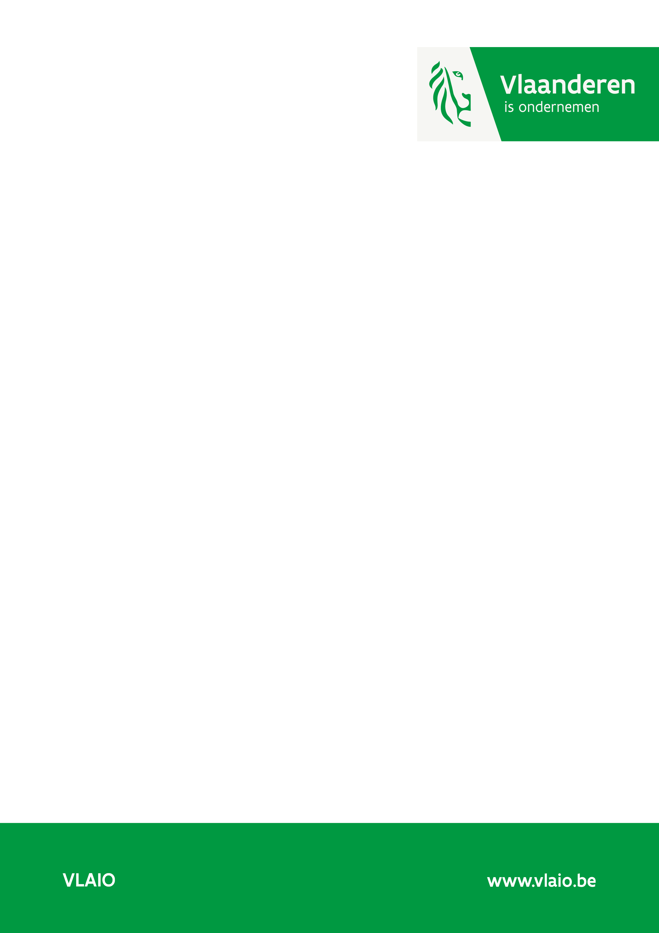

Application form
Research and Development projects

Annex for international and interregional projects

  - version may 2024

This annex is submitted together with the international or interregional project proposal to Flanders Innovation and Entrepreneurship. Each Flemish applicant in the international or interregional project consortium has to submit its own (separate) annex.
This section can be forwarded to the external experts. Any specific detailed information that VLAIO is not allowed to send to the experts should be included in a separate annex.
The annex(es) must be read together with the international/interregional project proposal. For this reason the focus of this annex should only be on the role of your (Flemish) company in the project, the nature of the activities to be carried out by the Flemish partners and the impact of the project results for your company in particular. This information will be used to determine the funding percentage and to evaluate the selection criteria regarding the impact of the project.
The selection criterium quality (project execution) will be assessed on the basis of the international/interregional project proposal and the international reviews.
It is recommended to carefully read the evaluation criteria (annex 1 of the 'Explanatory Document on Research & Development projects and Feasibility Studies') before writing your application.

Layman’s summary (max. 0.5 page)
This is where you provide a brief summary of your project, which can also be used for publication. Approval will always be requested before effectively publishing anything.

Guidelines:
- Answer these 2 questions:
  - What is the project about?
  - What is the added value of this project? What can it be used for in the future?
- Focus on the overall goal and expected impact rather than on the process itself.
- Replace difficult technical words with an easier synonym.
- Avoid (too) long sentences and complicated sentence structures, for example make two sentences out of one long sentence.
- Keep it concise, leave out what is less important for the target group.

Executive summary (max. 1 page)
Provide a brief summary of the project. Emphasize the objective(s) of the project. The objectives you define here will be copied verbatim to the funding agreement and will be used after the project to assess whether you were able to achieve your objectives. Please note that the funding agreement provides for best efforts, not results.
If the project application document is submitted in English, the summary must be provided both in Dutch and English.
Write this summary following this structure:

General purpose
First describe in a few sentences the overall objective of the international/interregional project consortium. Then describe in a few sentences what your company’s goal of the project is.
What knowledge are you aiming to acquire through this project? Describe the essence of the innovative product, process and/or service in question.

Concrete objectives and criteria
How far along the innovation development process do you aim to be after this project? Specify which concrete, verifiable results you wish to achieve (SMART). If possible, include quantitative targets, requirements, criteria and standards that you can use at the end of the project to test the extent to which you managed to achieve the expected results. If your project is expected to have a social impact as well, please formulate a specific social objective too.

Impact
Assuming that you manage to achieve the intended results, describe briefly what your company will do with these results (e.g. improve a new product, launch a new product, improve a process, ...). Describe the impact on your business (or the Flemish branch of your company): new activity, expansion/continuation of a main activity, sub-activity, ... Describe how the results will have an economic valorization and impact (jobs & investments) on Flanders. The total quantitative added value that the project will have for Flanders over the course of the valorization period has to create a leverage 10x compared to the requested funding (which is by default calculated on a valorization period of 5 years after the end of the project). If your project also creates societal added value, then describe it here shortly.
If several Flemish business partners are involved, describe the impact for each partner.

Track record (max. 1 page)
For each of the Flemish business partners, provide a clear description of the impact on previously received funding if you have received innovation funding from the Fund for Innovation and Entrepreneurship in the last 5 years. The aim is that we gain insight into the impact that the subsidized projects have had on your company.

If you have not received funding from the Fund for Innovation and Entrepreneurship in the last 5 years, please delete this section from the application.

Project number | The impact the project has generated since its completion
XXXXX
XXXXX

Project number | XXXX | XXXX | XXXX | …… | …..
Project name
Funding
Workforce*
R&D budget**
Investments**

*Start from the year of completion of your first project and show the process to the year in which the present project was submitted.

**Focus on R&D and investments made as a result of supported projects. Spillover effects within your company may also be included (briefly explain how these are linked to the supported projects).

***Only fill this in if projects with growth in labor productivity as added value for Flanders have been supported in the past. Labor productivity = Gross Value Added / number of FTE. For the definition of Gross Value Added, please refer to the Explanatory Document. The number of FTEs does not include freelancers.

Justification of the research/development typology
For research projects: indicate which of the work packages you are involved in are research and which ones are development, respectively.
For both development and research projects: describe the challenges and risks related to the tasks you perform in the different work packages you are involved in. Explain to what extent new knowledge, R&D activities, insights and skills are built up. For development, explain the distinction between engineering activities, routine improvements and implementation.
This part should be limited to 1 page.

Impact
In this section, we investigate how this project will create value for the Flemish business partners and for Flanders.
The recommended length of this section is approximately 10 pages per Flemish business partner, including figures. This section can be submitted to third-party experts. If you wish VLAIO to withhold certain information from these experts, please include it as an attachment.

2.1 Strategic importance of the project for the company
Indicate the strategic importance of the project for the company. Outline the company’s current position in relation to other companies and stakeholders with relevant knowledge.
Describe and substantiate how the project can make a difference to the company. Describe the position of the project -if necessary- within your broader industrial R&D/innovation strategy.

2.2 Added value of the project results for the company
Explain how the knowledge/results accrued within the context of this project can be converted into concrete innovations/results that will give the company a clear competitive edge. Describe these concrete innovations/results. How and to what extent will they contribute to the continued development (growth, retention, diversification, transition to other business models/activities/platforms, breakthrough innovations) of the company? If relevant, how will the results create the intended added societal value?
For large companies only (GO): frame the project in the company level roadmap, which should cover the following topics:
• Embedding in the Flemish ecosystem: structural collaborations with knowledge institutions and SMEs.
• Strategic roadmap of the Flemish branch. This must be in line with the policy priorities: Energy/climate, Circular economy, Environment, biodiversity and water management, Sustainable food and nutrition strategies, Mobility and smart cities, Education and competences, Health and care.
• Steps that the company (particularly the Flemish branch) wants to take in terms of sustainability.

2.3 Follow-up
Discuss the efforts (further R&D, engineering activities related to implementation, investments) that your company (and possibly its partners) will need to make after (or in parallel to) the project up to the expected.

2.4 Valorization in Flanders: economic impact
A quantified substantiation of the total intended valorization in Flanders is requested here (such as the economic value creation realized in Flanders during the valorization period, based on either (i) employment and/or investments or (ii) a growth in labor productivity following the project). These two options cannot be combined.

Option 1 – Added value for Flanders based on employment and/or investments
When the added value for Flanders is based on employment and/or investment, it is required that the total quantified valorization in Flanders during the valorization period is at least 10 times the support (achieving a leverage of 10). The standard valorization period is 5 years. After substantial motivation, a valorization period of up to 10 years may be observed. Demonstrating a leverage of 10 for a shorter valorization period (e.g. 3 years) is also a possibility.

Option 2 – Added value for Flanders based on growth in labor productivity
When the added value for Flanders is based on growth in labor productivity, it must first be justified why the tightness of the labor market does not allow the company to realize the impact through employment and/or investment. It is required that labor productivity is at least 50% higher 5 years after the end of the project than the labor productivity at the time of application. If the support needed is more than €250,000, the cumulative additional Gross Value Added (BrTW in Dutch) must be at least 10 times the support. If the support is less than or equal to €250,000, the cumulative additional Gross Value Added may be less than ten times the support. The valorization period for projects committed to labor productivity is fixed at 5 years and cannot be extended.

In case of multi-partner projects, each business partner should separately describe and quantify the impact of the project on their company. Here, one business partner or a group of business partners may choose impact based on employment and/or investment and the other business partners may choose impact based on growth in labor productivity. For both options, the minimum added value must be achieved.

The impact for Flanders is best demonstrated in tabular form, a possible table structure of which is given at the end of this application document for each option.

Consider the 5-year period (or 10-year period, if justifiable) after the project and describe what you expect will happen in Flanders (continuation of R&D during the follow-up process and/or business activities during the commercialization of the project results). What positive consequences will this have for Flanders (jobs, investments, growth in labor productivity, embedding, improved collaboration with the Flemish innovation ecosystem, ...)? Be as specific as possible.

These indirect profits or savings should preferably be presented in a table showing the structure of the business case, a conceptual table can be found at the end of this application document (revenue).

2.5 Societal Impact
If your innovation is expected to have societal impact, please detail this impact here.
Projects can have societal impact on several domains. In the Guidelines, you will find a non-exhaustive list of domains in which projects can have potential societal impact. Indicate which domains will be impacted by your project and explain why.
Estimate the potential net monetary profit worldwide (costs saved and/or profits realized), and if applicable, explain how this relates to the Flemish ecosystem. In addition to direct profits or savings as described in the economic impact subsection, your project may lead to savings or gains related to the environment, mobility, sickness absence, etc. that affect a broad base of stakeholders in Flanders (businesses, social sector, government or citizens).
If your project does not have a specific societal impact, you can leave this section blank. Projects with a negative societal impact are not eligible for funding.

2.6 Intellectual Property
Can the results of the project be protected? What is your strategy in terms of intellectual property? Take into account the possible impact of the European patent with unitary effect - simply called unitary patent or unitary patent - which came into effect on 1 June 2023.
In case of cooperation (with business partners, research institutes, subcontractors): what are the basic principles for mutual agreements? Please provide an explanation of, among other things, property rights to project results, user rights to project results and/or necessary background knowledge.

2.7 SWOT with regard to the valorization case
Discuss the strengths and weaknesses of the applicant company or companies, as well as important external factors (market, competition, environmental factors, ... both opportunities and threats) related to the valorization of the project, and if applicable, related projects. Indicate how you will respond to these strengths and weaknesses.
Discuss which measures are being taken in the field of cyber security, both viewed more broadly at company level and specifically for the innovation for which funding is requested. (Things that are already included during the project, to support the innovation, must be stated in the work plan.)

Optional: additional detailed information
If you wish to submit detailed information that should not be relayed to third-party experts, e.g. a business plan, please upload a separate file (Appendix) along with your digital submission.

Added value of the funding
Why is Flemish funding important for your project?
Explain why this project is commercially challenging, impossible or less viable without funding from VLAIO.

Project with possible military affinity (if applicable)
For more information about submitting projects with possible military links, please click here (available only in Dutch).
If this subsection does not apply to your project, you can leave it out.
If your project has potential military links, please indicate which section of the Military List or Dual Use list your proposed development belongs to.

If the aim of the project is to develop products or systems included in the Dual Use list, you must clearly indicate and explain the expected revenue of the civil and military applications, respectively, in the business case for your project (see 1.2 Expected Opportunities for Valorization).

If your project falls within the scope of sections ML5, ML6, ML7f-i or ML8-ML22 of the military list or the Dual Use list, and if your business case clearly specifies that the process/product/service in question mainly has military applications, your application will be submitted to the Ethical and Strategic Advisory Committee for evaluation. In that case, you will be asked to complete a self-evaluation during the evaluation process.

Table of economic value added for Flanders

Option 1 - Added value for Flanders based on employment and/or investment

Impact calculation based on employment and/or investment | XXXX  (year) | XXXX | XXXX | …… | …… | Total
Extra employment because of the project (break down per profile such as employees, vendors, R&D, etc.) - to be expressed in FTEs
Sustained employment because of the project - to be expressed in FTEs
Payroll costs - new hires
Payroll costs - staff retention
Project-related investments
....

Note that the increase in revenue that can be realized thanks to the project is not part of the leverage calculation. The input for the leverage calculation consists only of labor costs and investments as calculated is the table above.

Option 2 - Added value for Flanders based on growth in labor productivity

- The table is best constructed based on the definition of Gross Value Added (BrTW) as described in the Explanatory Document. Labor productivity (AP in Dutch) is calculated as AP = BrTW/FTE. As explained in the Explanatory Document, the number of FTEs must remain virtually constant for eligibility. This means that the growth in labor productivity is primarily realized through an increase in BrTW. It is therefore important to document the factors that determine the BrTW in your company and those that are impacted by the project results. Also, assumptions need to be substantiated and you must indicate why they are realistic.

- The BrTW can increase because of:
  - an increase in operating revenue. This is typically an increase in sales due to new or improved products, services or processes. This has already been justified in the table under the heading '2.4 Valorisation in Flanders - Economic Impact';
  - a decrease in operating costs: it may be that thanks to the project, fewer raw materials will be needed for production, fewer operational subcontracting costs will be required, less energy or water will be consumed, fewer (external) IT costs are necessary, the project will lead to more predictable and efficient inventory management, etc.

Impact calculation based on growth in labor productivity | On request | XXXX (= 1 year after end of project) | XXXX (= 2 years after end of project) | XXXX (= 3 years after end of project) | XXXX (= 4 years after end of project) | XXXX (= 5 years after end of project)
Calculation BrTW
- Factor X that affects the BrTW due to the project results
- Factor Y that affects the BrTW due to the project results
- …
- Total of the factors of the BrTW that are not affected by the project results
- Evolution BrTW (= sum of the rows above)
Evolution of FTE (permanent employees only, not freelancers)
Total return for Flanders
- Evolution AP = BrTW / FTE
- Growth in BrTW (incremental compared to starting value) | N/A
- Growth in BrTW (cumulative) | N/A

Conceptual example of a table to support the business case
Start from when your project ends (first column) to 5 years after the end of the project (penultimate column). Indicate what assumptions your numbers are based on.

Inkomsten | XXXX  (jaar) | XXXX | XXXX | …… | …… | Totaal
Inkomsten uit product/dienst X op basis van de business drivers (voeg hiertoe extra kolommen of rijen toe volgens noodzaak en indien relevant op te splitsen volgens de situatie met en zonder project)
Inkomsten uit product/dienst Y op basis van de business drivers (voeg hiertoe extra kolommen of rijen toe volgens noodzaak en indien relevant op te splitsen volgens de situatie met en zonder project)
…
Totaal inkomsten

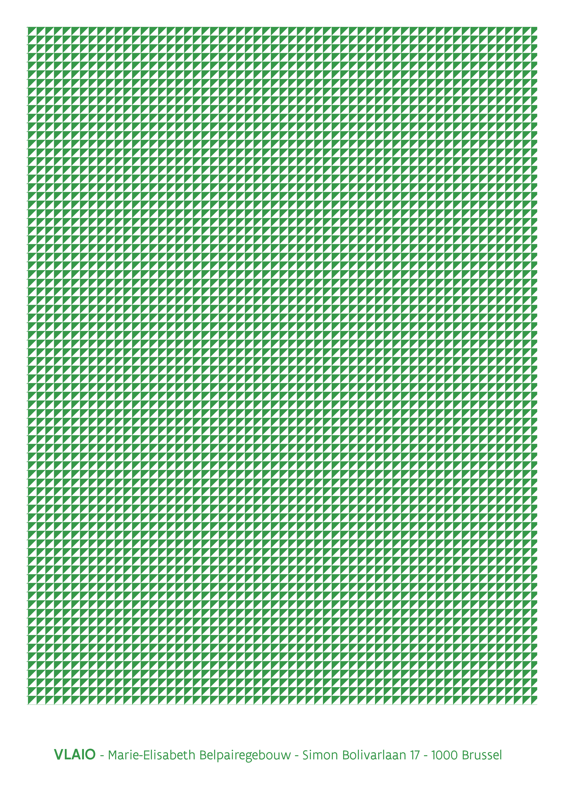

The distinction between research and development is explained in the explanatory document.
Make sure to clarify how the staff costs are structured (how many FTE of which staff type and the salary costs per staff type). If relevant, this can be broken down in the table.
No assistance can be provided to companies that achieve all or part of their growth in labor productivity through layoffs. This means that the number of FTE must remain virtually constant during the valorization period.

