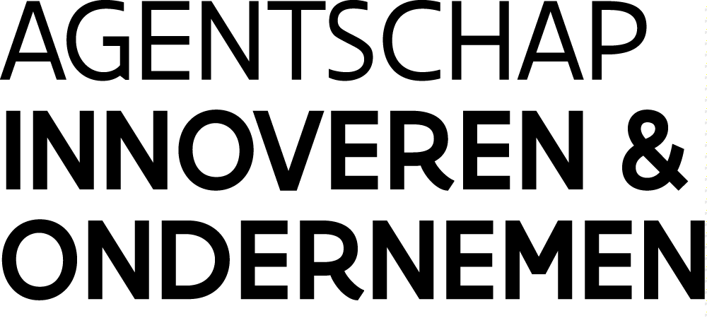
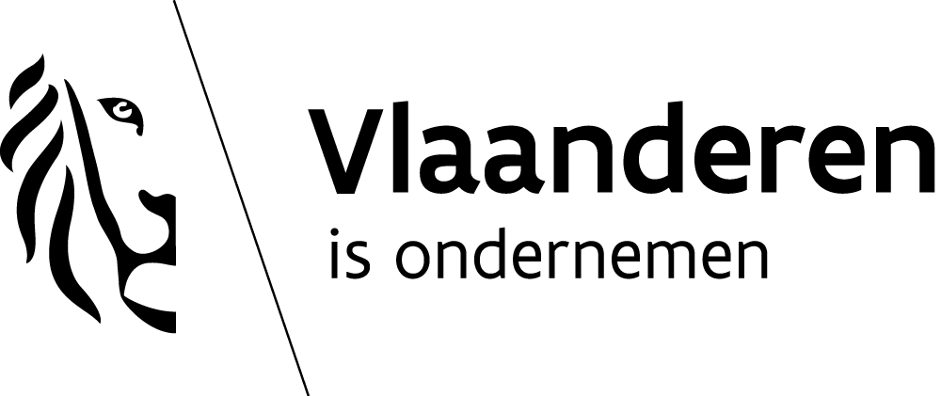

PRESS RELEASE MARCH 2019

Flanders, specialist in underwater shoots
VLAIO and Lites invest in largest indoor underwater studio in Europe

A submarine disaster. Waves of 1m high. A tidal wave with much higher waves. At Lites’ indoor underwater studio in Vilvoorde the press of a button is all it takes to create a world of imagination. With €1.1 million in subsidies from Flanders Innovation & Entrepreneurship (VLAIO), Lites has developed from a classic rental company for filming equipment into an international complete supplier for the TV and movie industry. The brand-new underwater studio with a maximum water depth of 10 metres and a water surface area of up to 1250 m² is the most advanced and best equipped underwater studio in the world.

One of the major assets of the indoor underwater studio in Vilvoorde is the fact that all water effects can now be shot indoors. The effects are realised with great reliability and with great attention to safety. Lites CEO Wim Michiels: “In my experience as an underwater camera man, the existing indoor underwater studios were inadequate for filming major water effects. An outdoor studio offers greater possibilities but then other factors such as cold water, unpredictable weather conditions and a lack of control in terms of water quality come into play. This makes the filming of big water scenes a time-consuming and laborious affair - in other words expensive and a production risk. Lites Water Studio offers film projects much greater certainty and stability so the scenes can be shot within the allotted budget.”

The 24 x 21 x 9 m studio is unique for Flanders and the world thanks to high-tech gear that makes a host of special effects possible. Lites keeps the water at a constant 32 degrees, making lengthy underwater scenes much easier to shoot. The pool is also equipped with an oversized water filtering system capable of creating different water looks to simulate different weather conditions ranging from cloudy to sunny. Also, the appearance of the water can be altered from crystal clear to polluted and from river to ocean water. Thanks to large movable platforms and overhead cranes sets of up to 25 tonnes can be built and then submerged to the right depth. Moreover, 18 tonnes of water can be sent crashing down from three towers with adjustable ramps. “Both from a technical and creative standpoint the possibilities have grown tremendously, in a cost-efficient and sustainable way”.

Flemish know-how

Lites’ transformation from an audiovisual rental company into a complete audiovisual service provider is the result of an €23 million investment project. The icing on the cake was the construction of an innovative studio complex that houses the most advanced underwater studio in Europe. For this Lites received €1.1 million in strategic transformation support from the Flemish government. The unique underwater studio and specialised know-how will attract international productions which would otherwise not opt for Belgium.

Flemish Minister of Innovation and Employment Philippe Muyters: “Flemish subsidies have substantially augmented Lites’ own contribution, convincing the bank and private investors to become involved in the project. In addition, this financial support puts Flanders on the world map as a specialist in underwater shoots. Lites also creates employment, not only for its own employees but also for freelancers and companies in the audiovisual industry and even suppliers from outside the industry.”

Mark Andries, General Manager Flanders Innovation & Entrepreneurship: “This project illustrates how we were able to combine two important policy areas, economy and innovation. Lites can now provide specialised services that create a high-quality audiovisual product. As a company Lites has shown in recent years that transformation works and has a positive impact on the continued development of the audiovisual industry in Flanders.”

In addition to the underwater studio Lites has also built ‘dry’ film studios so major international productions can be shot entirely in Vilvoorde. Lites has already contributed equipment and/or high-quality underwater footage to the following films, series and TV productions:
• internationally: Kursk, The Team, The Missing, Versailles, Baptiste, I Kill Giants, Les Misérables, The Fifth Estate, The White Queen, Parades End, Death in Paradise, Iron Sky…
• nationally: Girl, Kid, Loft, De Dag, Tabula Rasa, Undercover, Bastaard, Engel, Koereur, D’Ardennen, Cargo, De Kampioenen, De Behandeling, Home, Los Flamencos, Galloping Mind, Tot Altijd, Smoorverliefd, Mega Mindy vs Rox, Ciel Flamand, Dode Hoek, Het Tweede Gelaat, Unité 42, Als De Dijken Breken…

Mark Andries, General Manager Flanders Innovation & Entrepreneurship:

Flanders Innovation & Entrepreneurship (VLAIO) is the point of contact of the Flemish government for entrepreneurs in Flanders. VLAIO stimulates and supports innovation and entrepreneurship and contributes to the creation of a favourable business environment in conjunction with a host of partners.

About Lites – www.litesstudios.com

Lites is a Belgian company with 30 full-time staff and branches in Vilvoorde, Brussels and Amsterdam. LITES Rental rents out film cameras, lenses and lighting equipment for Belgian and European film and TV shoots. The new studio complex consists of 5 film studios. The 3 big studios are fitted out according to the highest standards for international film shoots: acoustics, light suspension, available techniques, and an adjacent space with an eye for aesthetics and working comfort.

The underwater studio is the only one of its kind in the world. The pool with permanently heated water is available throughout the year for underwater shoots with complete control over the water effects. Moreover, the studio can be flooded in its entirety to create an even larger water surface area (expansion from 480 to 1250 m²). All water pumps, water buffers and technical installations are built-in in the cellars.

For more details

Tinne Stukkens
Cabinet Philippe Muyters, Flemish Minister of Employment, Economy, Innovation and Sports
+32 498 36 37 85
tinne.stukkens@vlaanderen.be

Karolien Goossens
Communication Manager VLAIO
+32 486 68 50 39
karolien.goossens@vlaio.be

www.vlaio.be/pers

